SI 608 Project Report

* Network Structure
  + Year
  + Disease Type

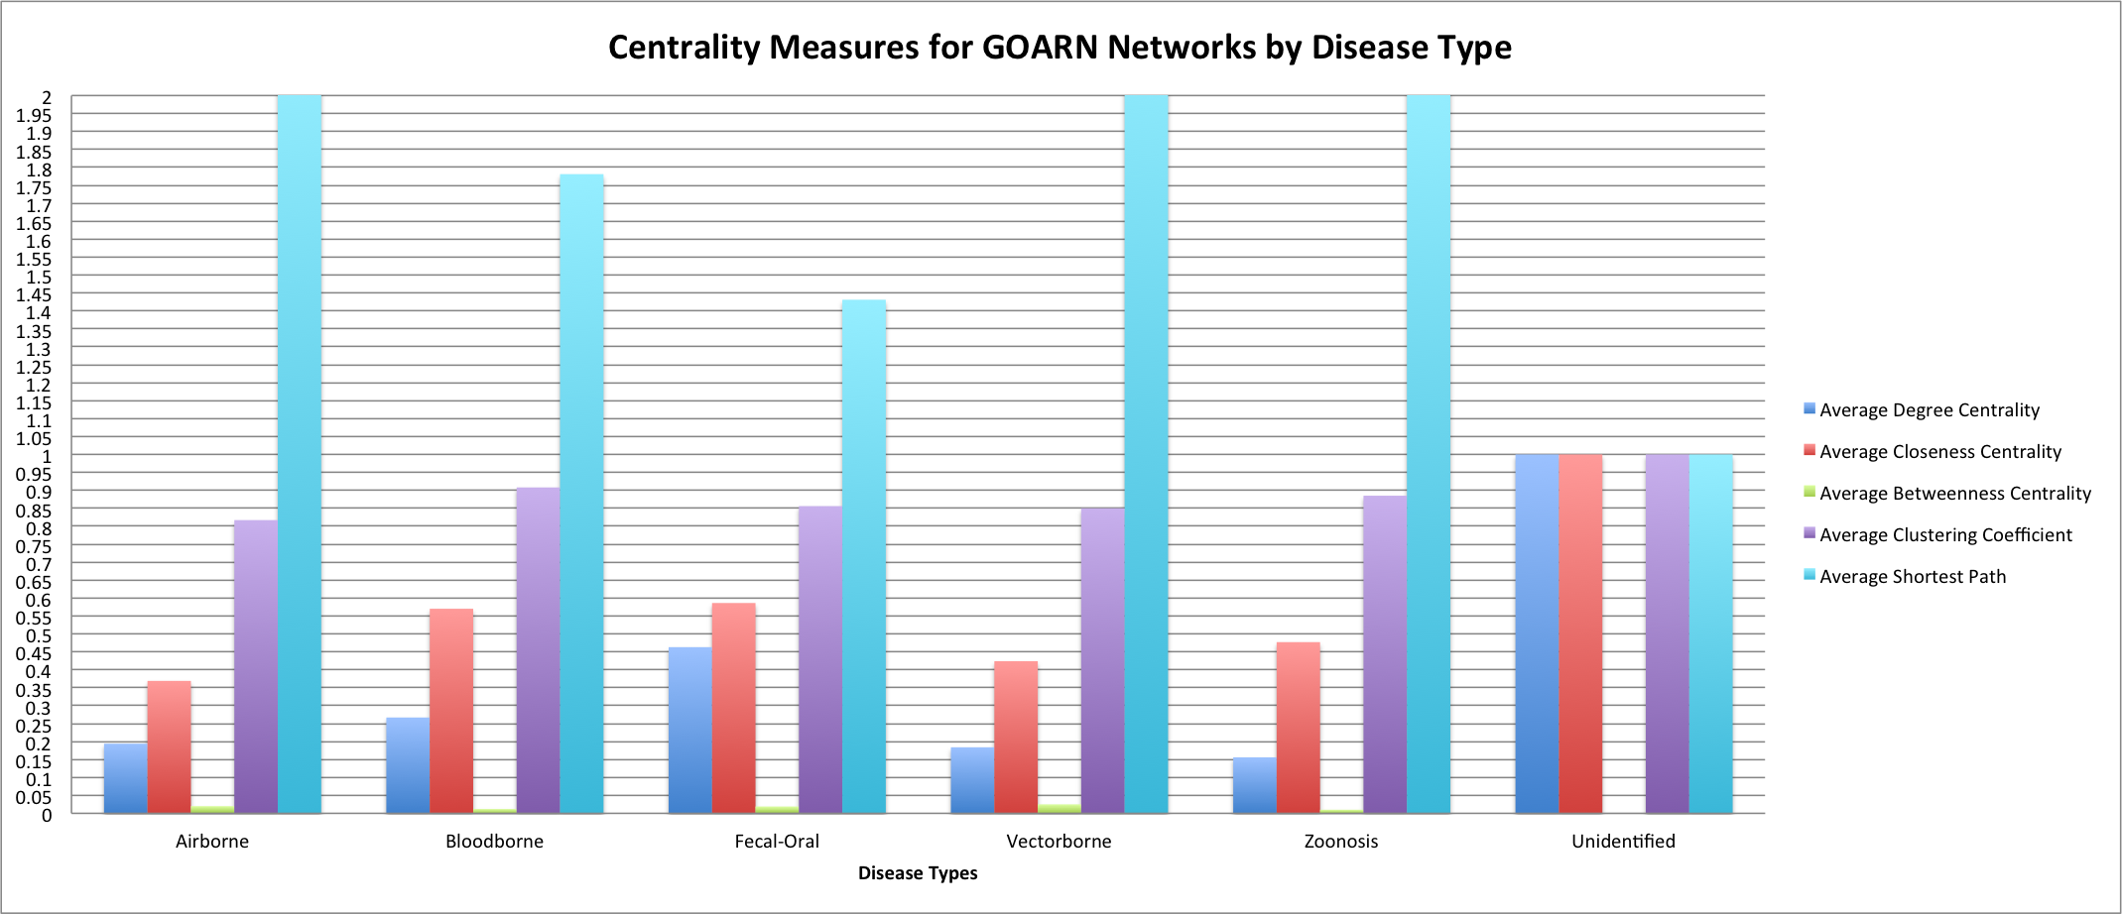

* Network Resilience
  + WHO
    - Removing WHO as a node
    - Removing events with WHO participation
  + CDC
    - Removing CDC Atlanta as a node
    - Removing events with CDC Atlanta participation